In Our Hands Fund Application Guidelines

About the fund
We are offering community grants of up to £1,000 for people living in:
- West Hendon
- Burnt Oak
- and Colindale.
The funding is for local people with ideas that bring communities together, start something new, or make their area a better place to live.
These guidelines explain how to apply to the In Our Hands Fund.
You do not have to apply on your own — you can ask someone to help you, and this will not affect your application.
If you have any questions or need the information in a different format, please contact:
Divya at participation@artsdepot.co.uk

What can the grant support?
Projects that:
- Bring people together and strengthen relationships between neighbours, groups, and communities
- Create shared cultural or creative experiences in local spaces
- Celebrate local culture, creativity, or heritage
- Support wellbeing, care, and mutual support
- Build people’s skills or confidence
- Create joyful, welcoming, and inclusive spaces for people to meet
- Respond to local needs in imaginative and practical ways
- Make positive use of underused or overlooked spaces or improve the local built environment.
- Test out ideas that could grow into longer-term local projects
- Help people feel more positive, connected, and engaged with their local area

Who can apply?
You can apply if you:
- Live, work, study, or have a close connection to West Hendon, Burnt Oak, and Colindale (inclusive of North and South)
- Are planning a project that will take place in West Hendon, Burnt Oak, or Colindale (North & South)
- Have an idea that benefits local people
- Can deliver the project locally between March 2026 – end of December 2026
- You have a UK bank account - we need this so we can pay you your grant.

More Information
- You do not need previous funding experience – first-time applicants are very welcome
- We encourage applications from people who:
  - Experience mental or physical health conditions or disability
  - Are neurodivergent or have learning disabilities
  - Have lived experience of substance use or being a survivor
  - Are from working-class backgrounds
  - Are LGBTQIA+
  - Are Black, Asian or from minoritised ethnic communities
  - Are from Romani, Traveller, or Gypsy communities
- If you are under 18, an adult (18+) must apply on your behalf and will receive the grant

What can I apply for?
- Projects could include:
- workshops,
- events,
- creative activities,
- food or growing projects,
- walking groups,
- storytelling,
- skill-sharing
- book clubs
- community gardens
- one off event, workshop or activity, or a series of activities
- or something completely new.
- Funding can support: training or personal development if it clearly helps you deliver a project that benefits local people.
- We welcome varied projects, not just arts related ones.
What you cannot apply for:
- Access to artsdepot spaces: While your project may take place locally, we cannot guarantee use of Artsdepot venues or rooms for project activities. Applicants should plan for alternative spaces in their local area.
- Theatre productions or large-scale performances: The grant is designed for small-scale community projects, and funding cannot be assumed to cover full theatre productions, ticketed events, or large-scale performances.

How much can I apply for?
- Grants up to £1,000 (you don’t need to apply for the full amount)
- Funding can be used for a wide range of things including:
- materials,
- space hire,
- artist or facilitator fees,
- refreshments
- access costs,
- training,
- and other reasonable project expenses

Support & Accessibility
If you are interested in applying but would like to know more or need some support or guidance you can:
- Join a drop-in Zoom session to ask questions or get guidance on your application (please see our website for updates)
- Attend an in-person drop-in on the scheduled days (please see our website for updates)
- Email Divya at participation@artsdepot.co.uk with questions or support needs
Please note: We have a Community Producer (1 person, working part-time), so we may not be able to respond immediately to every request, but we will do our best to help.
Your application doesn’t need to be perfect – the online drop in sessions are there to support you.

Timeline
- Applications open: Thursday 29 January 2026
- Applications close: Tuesday 24 February 2026, 10am
- Drop-in sessions: Wednesday 11 and 18 February 2026
- Applications reviewed: Week beginning 23 February 2026
- Decisions shared: Week beginning 2 March 2026

How to submit your application
You can apply in three ways. You can ask someone to help you. Choose what works best for you.

Apply online
- Complete the Microsoft Form, and press submit.

Apply by email
- Download and complete the Word application form
- Save the file as: Your Name – In Our Hands Fund Application
- Email it to participation@artsdepot.co.uk
  - You may include any images or links relevant to your project (optional)

Apply by post or drop off in person at artsdepot Box Office:
Send your application to:
Divya Satwani
artsdepot
5 Nether Street
Tally Ho Corner
North Finchley
London N12 0GA

What happens if I am successful?
Successful applicants will:
- Receive funding to deliver their project
- Be offered light-touch support during the project
- Participate in completing a short evaluation report including:
  - Capturing numbers of participants, demographics, and postcode (if possible)
  - Sharing photos
  - Answering short reflective questions on the project.

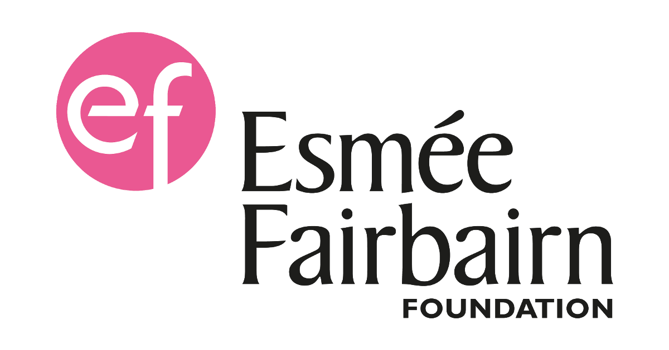 Supported by The Esmée Fairbairn Foundation

