In Our Hands Fund Application Guidelines
About the fund
We are offering community grants of up to £1,000 for people living in West Hendon, Burnt Oak, and Colindale, as part of our work to support creative communities in Barnet.
The funding is for local people with ideas that bring communities together, start something new or make their area a better place to live.
These guidelines explain how to apply to the In Our Hands Fund. You do not have to apply on your own — you can ask someone to help you, and this will not affect your application.
If you have any questions or need the information in a different format, please contact Divya at participation@artsdepot.co.uk.
This fund is part of artsdepot’s Beyond Our Walls programme funded by the Esmee Fairbairn Foundation.

What can the grant support?
Projects that:
- Bring people together and strengthen relationships between neighbours, groups, and communities
- Create shared cultural or creative experiences in local spaces
- Celebrate local culture, creativity, or heritage
- Support wellbeing, care, and mutual support
- Build people’s skills or confidence
- Create joyful, welcoming, and inclusive spaces for people to meet
- Respond to local needs in imaginative and practical ways
- Make positive use of underused or overlooked spaces or improve the local built environment.
- Test out ideas that could grow into longer-term local projects
- Help people feel more positive, connected, and engaged with their local area

Who can apply?
You can apply if you:
- Live, work, study, or have a close connection to West Hendon, Burnt Oak, and Colindale (inclusive of North and South)
- Are planning a project that will take place in West Hendon, Burnt Oak, or Colindale (North & South)
- Have an idea that benefits local people
- Can deliver the project locally between March 2026 – end of December 2026
- You have a UK bank account - we need this so we can pay you your grant.

More Information
- You don’t need previous funding experience – we welcome first-time applicants.
- We encourage those who experience mental health conditions, physical health/disability, sensory impairment, learning disabilities, neurodivergence, substance use, identify as survivors, and those from working-class backgrounds, as well as LGBTQIA+, and Black, Asian and minoritised ethnic communities or traveller communities to apply.
- Please note: If you are under 18 years old and interested in applying you will need an adult (18+) to apply on your behalf. They would also be the grant recipient.
What can I apply for?
- Projects could include workshops, events, creative activities, food or growing projects, walking groups, storytelling, skill-sharing, or something completely new.
- Funding can support training or personal development if it clearly helps you deliver a project that benefits local people.
- Projects do not have to be arts-related – they could include community gardens, book clubs, skill-sharing sessions, or other creative and practical ideas that bring people together.
- It can be a one off event or workshop, or could be a series of activities.

What you cannot apply for:
- Access to artsdepot spaces: While your project may take place locally, we cannot guarantee use of artsdepot venues or rooms for project activities. Applicants should plan for alternative spaces in their local area.
- Theatre productions or large-scale performances: The grant is designed for small-scale community projects, and funding cannot be assumed to cover full theatre productions, ticketed events, or large-scale performances

How much can I apply for?
- Grants up to £1,000 (you don’t need to apply for the full amount)
- Funding can be used for: materials, space hire, artist or facilitator fees, food, access costs, training, and other reasonable project expenses

Support & Accessibility
If you are interested in applying but would like to know more or need some support or guidance you can:
- Join a drop-in Zoom session to ask questions or get guidance on your application (please see our website for updates)
- Attend an in-person drop-in on the scheduled days (please see our website for updates)
- Email Divya at participation@artsdepot.co.uk with questions or support needs
Please note: We have a Community Producer (1 person, working part-time), so we may not be able to respond immediately to every request, but we will do our best to help.
Your application doesn’t need to be perfect – the Zoom sessions and emails are there to support you. Using these options with clear questions will help us give you the best support we can.

How to Submit Your Application
You can submit your application online, by email, or by post. Choose the option that works best for you.

Online
- Fill in the Microsoft Form, and press submit when complete!

By Email
- Download the Word document version of the application form and type in your answers
- You can ask someone to help you complete the form
- Save the document as:
Your Name, In Our Hands Fund Application
- Use the subject line:
Your Name – In Our Hands Fund Application
- Email your application to participation@artsdepot.co.uk,
  - Feel free to email us with any images you’d like to share (optional – you can attach these or include a web link)

By Post
Send your completed application to:
Divya Satwani
artsdepot
5 Nether Street
Tally Ho Corner
North Finchley
London
N12 0GA

What happens if I am successful?
Successful applicants will:
- Receive funding to deliver their project
- Be offered light-touch support during the project
- Participate in completing a short evaluation report including:
  - Capturing numbers of participants, demographics, and postcode (if possible)
  - Sharing photos
  - Answering short reflective questions on the project

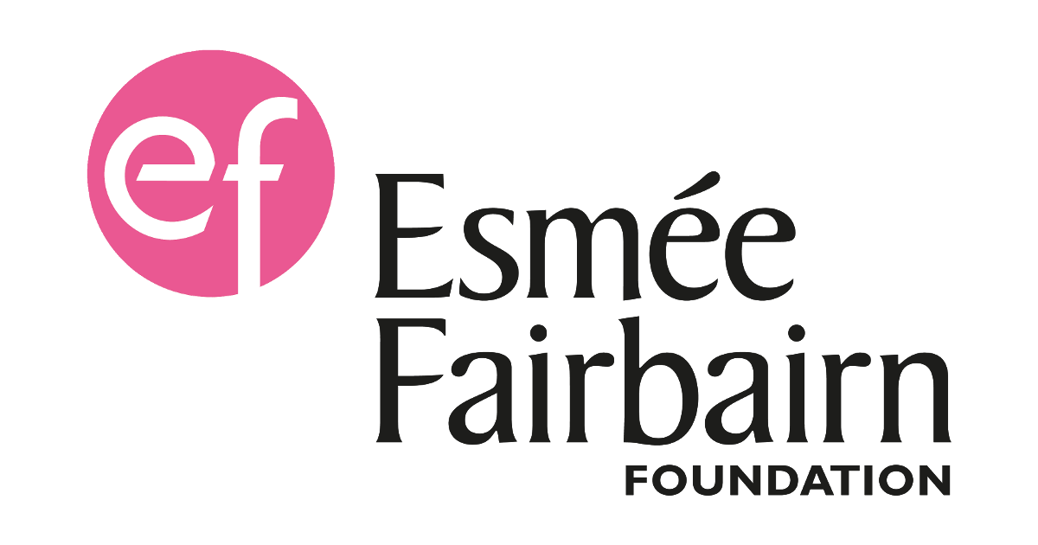 Supported by The Esmée Fairbairn Foundation

